README template

Table of Contents

1. Introduction
2. Requirements
3. Recommended modules
4. Installation
5. Configuration
6. Troubleshooting

**Introduction:**

The hiring manager of our client would like to be able to view a potential employee’s deployed portfolio of work samples so that they can assess whether they are a good candidate for an open position. They would like to be able to load the candidate’s portfolio, see their name, a recent photo, and links to the sections about them, their work and how to contact them. They would like to be able to link to the various sections and be able to scroll to the corresponding section. The first application photo should be larger in size than the other photos. They would like responsive layouts on various screens and devices.

For a full description of the client requests, got to

<https://courses.bootcampspot.com/courses/451/assignments/7274?module_item_id=112375>

A sample of the mock-up can be seen here:

<https://courses.bootcampspot.com/courses/451/assignments/7274?module_item_id=112375>

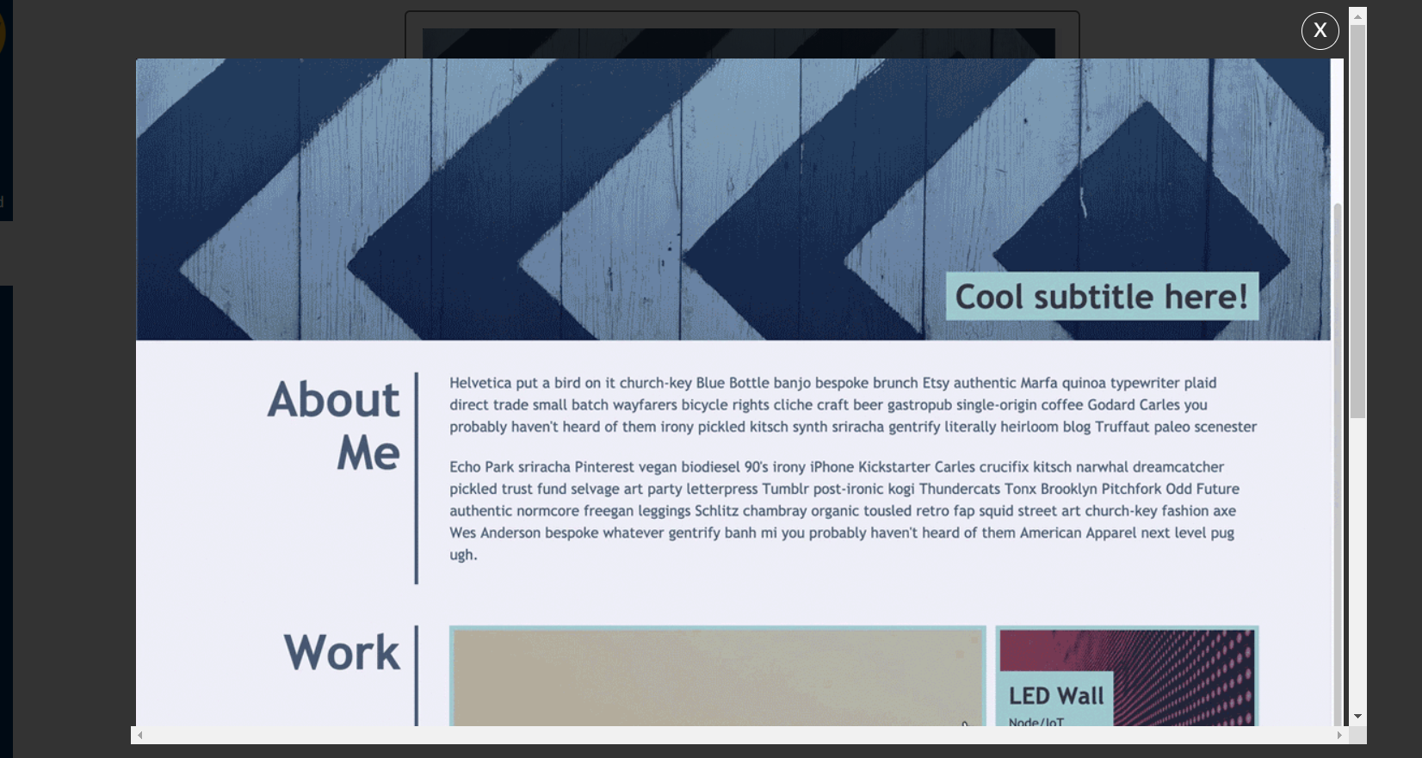<https://courses.bootcampspot.com/courses/451/files/390441/preview>

**Requirements:**

This project requires the following programs:

GitHub

GitBash

VS Code

Chrome

HTML

CSS

Directions from the BootCamp

Images

For all the data and images required for this project, go to:

<https://github.com/sethtuman3111/Challenge2>

**Installation**

Download the data and images fromGithub <https://github.com/sethtuman3111/Challenge2>

VSCode by using GitBash. Edit both the Index and CCS style sheets in VSCode. Execute and launch the program in Chrome.

**Configuration:**

The client would like codebase that follows accessibility standards so that the site is optimized for search engines. We need to create the source code and find semantic HTML elements. The HTML elements should follow a logical structure independent of styling and position. Image elements should also have alt attributes. Heading attributes should fall in sequential order. The Title element should have a concise descriptive title.

For comprehensive configuration instruction, see

<https://courses.bootcampspot.com/courses/451/assignments/7274?module_item_id=112375>

Troubleshooting & FAQ

This section intentionally left blank.